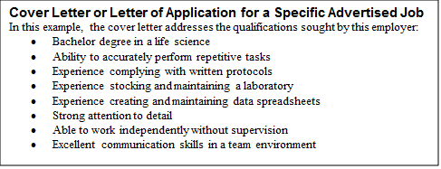
December 1, 20XX

Mr. Al Gee
Manager, Human Resources
Health BioScience, Inc.
51 University Street
Seattle, WA 98191

Dear Mr. Gee:

I am applying for the position of Lab Assistant at BioScience Inc. that was recently posted on Western Washington University’s Handshake platform. With strengths in attention to detail, team collaboration, and communication, it has been a goal of mine to be part of a team that focuses on dynamic and emerging research. I am confident that my education and extensive experience in research and laboratory techniques will contribute to BioScience Inc.’s mission of advancing new scientific discoveries through innovative solutions.

BioScience is seeking a candidate with the ability to accurately perform repetitive tasks in compliance with written protocols while paying careful attention to details. As a Lab Assistant supporting research teams in Western Washington University’s Toxicology Lab, I conducted a variety of chemical analyses, each many times over. Every series had to be identical and accurate. To support research projects, I took the initiative to create and maintain spreadsheets, which facilitated timely analysis of detailed data. In an effort to meet precise research needs, I communicated closely with several teams to effectively maintain the lab’s stock of chemicals and other materials. Working without supervision, I made time management a priority and typically finished tasks ahead of schedule. This experience has prepared me to be a collaborative and detailed member of your team.

Navigating my own health issues growing up, the area of biology has always piqued my interest personally and professionally. I have thoroughly enjoyed what I have learned from my degree in cell biology and genetics, and it provides me with knowledge and skills which I can contribute to your organization. For example, in my developmental biology lab I used the model organism Arabidopsis thaliana to investigate the mechanisms which control the balance between cell proliferation and differentiation during development. This study and the processes involved are directly relevant to research currently being conducted by BioScience Inc.

As someone who has personally been impacted by therapies developed from new scientific discoveries, I am excited to contribute my skills, experience, and passion for research to your company. I will follow up with you next week to make sure you have all the information you need. In the meantime, if you require additional information or would like to schedule an interview, I can be reached at (360) 676-0000 or rhbush@mail.com. Thank you for your consideration. I look forward to hearing from you to discuss this position further.

Sincerely,

Rose Bush

